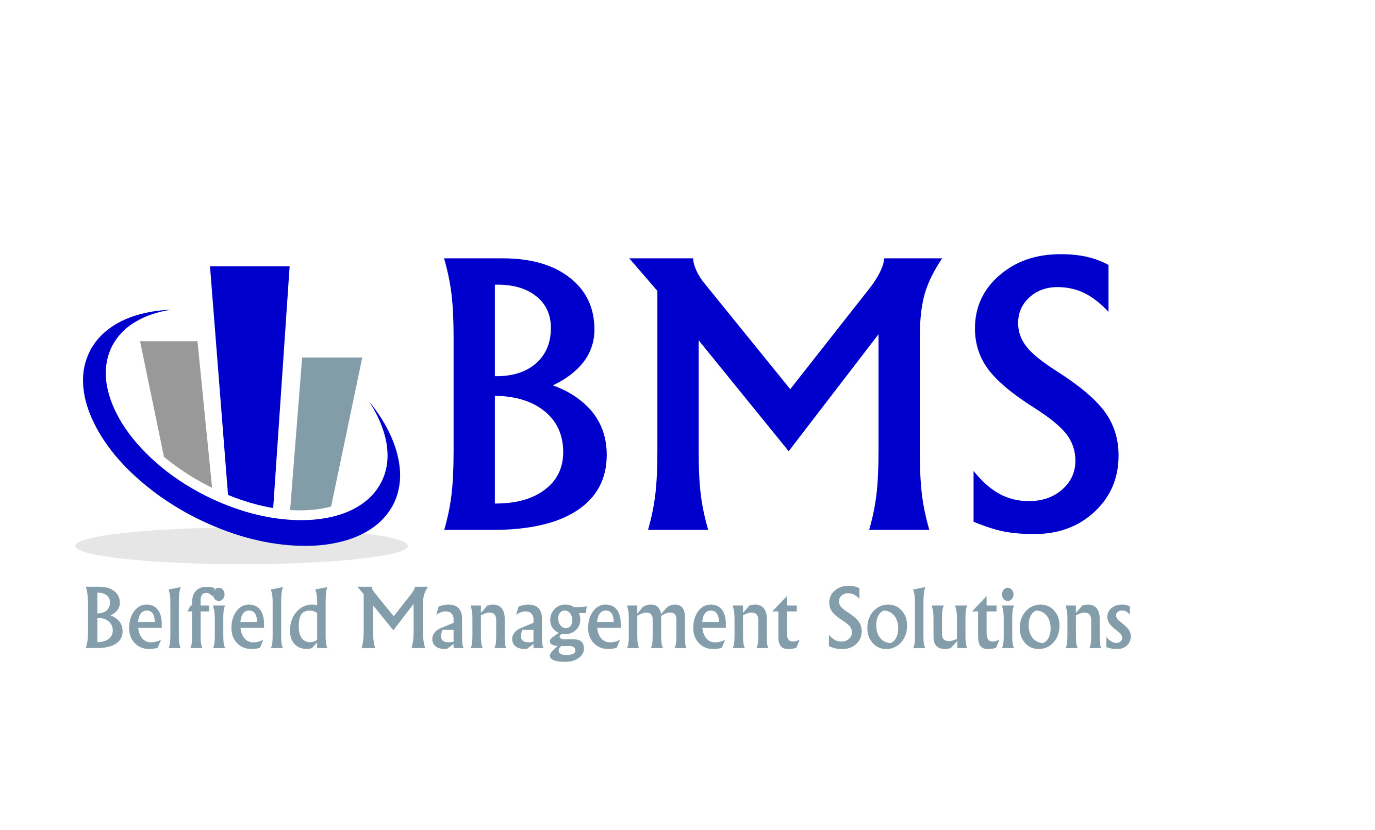
EMPLOYEE PERCEPTION SURVEY

This questionnaire is PERSONAL and CONFIDENTIAL. You cannot pass or fail; there is no right or wrong answer. Circle your answers accordingly. Do NOT put your name on this form. Thank you for your participation.

1. Do you believe this company is organized? | YES | NO
2. Do you believe this company works well as a team? | YES | NO
3. Does this company communicate well? | YES | NO
4. Does this company hold regular team meetings? | YES | NO
5. Do you understand the goals /objectives of this company? | YES | NO
6. Does this company have good morale? | YES | NO
7. Does this company have departmental friction? | YES | NO
8. Does this company have employee handbooks? | YES | NO
9. Does this company hold people accountable for performance? | YES | NO
10. Do you have a written job description? | YES | NO
11. Does this company have an effective training system? | YES | NO
12. Does this company have an employee turnover problem? | YES | NO
13. Does this company have any type of employee incentives? | YES | NO
14. Does this company give employee evaluations? | YES | NO
15. Does this company treat everyone fairly? | YES | NO
16. Is there any type of theft, waste or other loss? | YES | NO
17. Do you have modern costing and accounting controls? | YES | NO
18. Would you recommend this company for employment? | YES | NO
19. Does this company have good management leadership? | YES | NO

Circle all the words that best describe you today in this company:

Satisfied | Good judgment | Dissatisfied
Professional | Desires training | Desires a raise
Team player | Open-minded | Dependable

Circle all the words that best describes this company today:

Organized | Makeover needed | Disorganized
Out of control | Negative attitudes | Great
Visionary | Appreciative | Departmental friction
Back-stabbing | Failure to listen | Poor follow through

Circle the grade you would give this company: A B C D F

Why did you give the Company this grade?

If you were President of this company, circle which functions listed below would improve this company:

Better management planning | Inventory control
Rules followed by everyone | Improved software
Written policies and procedures | Budgetary controls
Better accountability | Improved sales
Better organization | Better equipment
Better communication | Better benefits
Improved morale | Incentives
Written job descriptions | Improved accounting
Terminate incompetent help | Qualified managers
Team meetings | Working as a team
Better training | Cross training
Performance guidelines  List at least five (5) placing a 1 in the most important and so on. | Performance reviews

1.
2.
3.
4.
5.
6.
7.
Comments:

